Project Index Page :

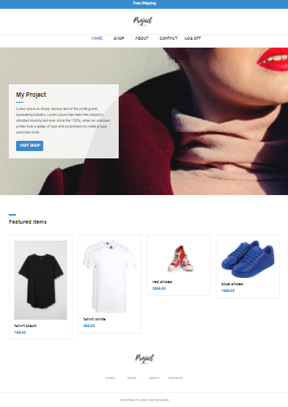

Project Admin Panel Index :

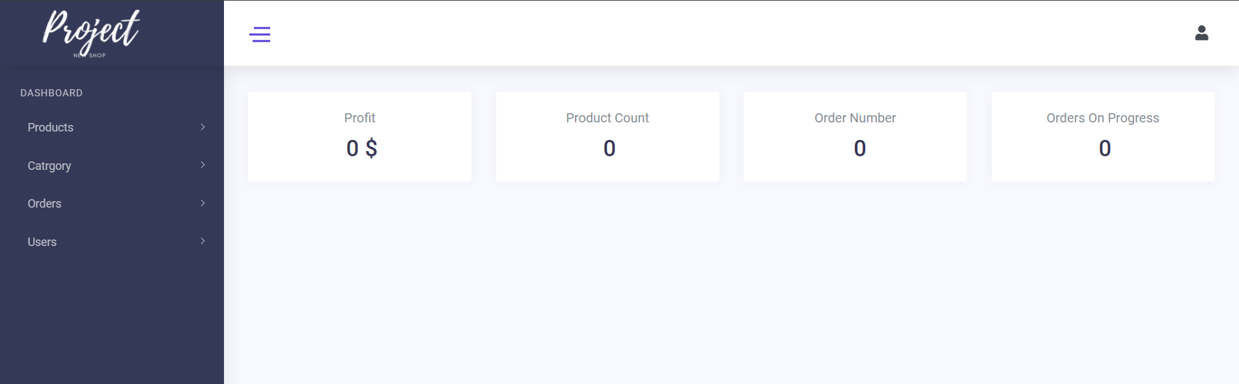

1 – Creating Models :

Product Model :

namespace MyApp.Models

{

public class Product

{

public int ProductID { get; set; }

public string ProductName { get; set; }

public decimal ProductPrice { get; set; }

public string ProductImage { get; set; }

public int CategoryId { get; set; }

public virtual Category Category { get; set; }

}

}

Category Model :

namespace MyApp.Models

{

public class Category

{

public int ID { get; set; }

public string Title { get; set; }

public virtual ICollection<Product> Products { get; set; }

}

}

Oredr Model : (Needs Work)

namespace MyApp.Models

{

public class Order

{

public int ID { get; set; }

public int ProducId { get; set; }

public DateTime OrderTime { get; set; }

public decimal Quantity { get; set; }

}

}

2- Create Migration and updating database Using The Nuget extention

PM>enable-migrations

PM>add-migration InitialModel

PM> update-database

3- Editing Create / Index Template for Products And Categories

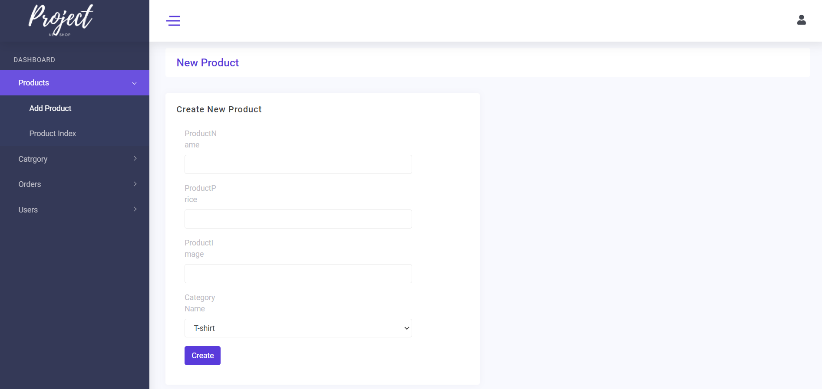

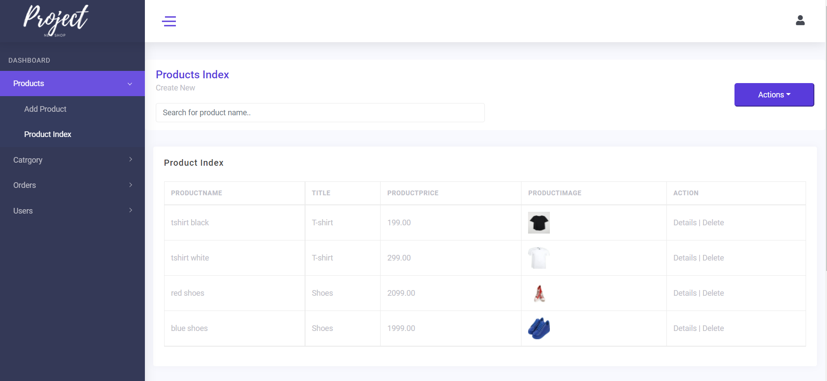

4 – Authentification :

Assigning a User to a Role

var roleStore = new RoleStore(new ApplicationDbContext());

var roleManager = new RoleManager(roleStore); await roleManager.CreateAsync(new IdentityRole(“CanManageMovies”));

await UserManager.AddToRoleAsync(user.Id, “AdminRole”);

Restricting Access :

[Authorize(Roles = “AdminRole”)]

if (User.Identity.IsAuthenticated) { … }

if (User.IsInRole(“AdminRole”) { … }